Career Exploration Assignment
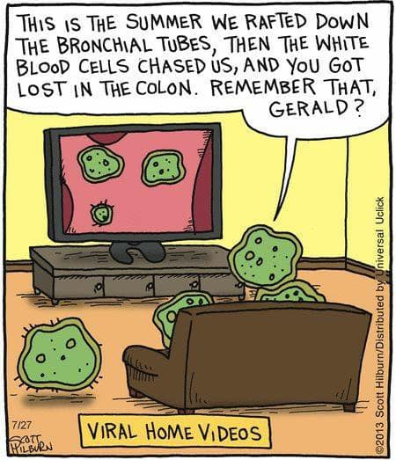
Ologies

You may ask… what does “ology” or “ologies” mean?

Ology or Ologies refers to “subject of interest, a branch of study”.

For example, if someone studies the mind and how it works, they may be a psychologist. If someone studies rocks and minerals, they may be a geologist.

In this class, we will have the opportunity to listen to various conversational science topics of your choosing. Choose 5 topics listed below that interest you and answer various questions in regards to that ologist. You’ll have a chance to learn about what they study, how they got into what they study, their favourite and least favourite things about what they study, learn about what they study, etc. Please note: there is some adult language with some of these episodes, if any of the language offends you, you can choose another episode that suits you better. It’s conversational science, these are real people who study real subjects/topics.

You can listen to the episode either three ways:

- Podcast App on your Phone
You can listen to the Podcast through the Podcast app if you have it on your phone by typing in the title “Ologies”. Once you have found the Ologies podcast in the app on your phone, download it, and then find the episode you wish to listen to (make sure it is on the list I’ve provided). Side note: I’ve attached on the list of episode topics which number episode it is.

- Go to the Website www.alieward.com/ologies
If you’d rather listen over the computer or don’t have a podcast app, you can go to the website www.alieward.com/ologies and find the topic you are looking for on there. In the top right there is a button called “Ologies”, click it and it should bring up a list of the ologies episodes in order from most recent displayed first to the oldest. You may need to click the “older” button at the bottom of the screen to display older episodes. Or you could search the key word in the search bar and it may show up. I have attached on the list of episodes topics which dates they were released to help you find the episode better.

- Go to the website https://www.alieward.com/ologies-extras?rq=transcripts
If you’d rather read the transcripts (read what they say) instead of listening, you can read them at this website. The choices are limited as to which episodes you can listen to. I’ve listed which episodes are transcribed as well as listen. The bleeped versions of the episodes are also on this page.

To do:
- Pick a topic from the list provided
- Listen to the interview fully either on the website or through the Podcast App
- Answer questions based on episode
- Submit on due date

Career Exploration Submission | Topic of Choice  *Include both scientific name and topic  Ex: Paleontology (Dinosaurs) | Date Due
1
2
3
4
5

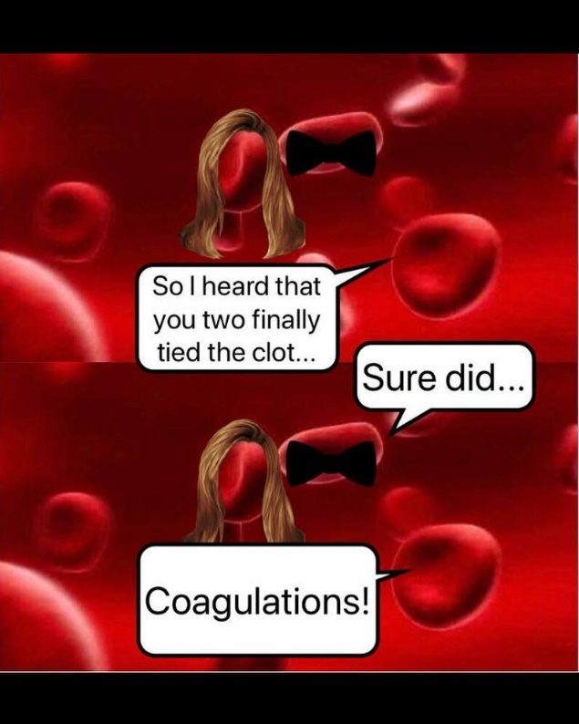

List of Approved Episodes
Episode Topic | Episode #:  (Podcast App) | Date Released  (Online) | Transcript Available
Volcanology  (Volcanoes) | 1 | September 20th, 2017 | Yes
Primatology  (Monkeys and Apes) | 2 | September 25th, 2017
Paleontology  (Dinosaurs) | 3 | October 5th, 2017
Gemology  (Crystals and Gems) | 4 | October 10th, 2017 | Yes
Horology  (Watches) | 5 | October 17th, 2017 | Yes
Ornithology  (Birds) | 8 | November 7th, 2017
Cosmetology  (Glam/Grooming) | 9 | November 14th, 2017
Entomology  (Insects) | 11 | December 4th, 2017 | Yes
Cosmology Part 1  (Universe) | 12 | December 12th, 2017 | Yes
Cosmology Part 2  (Universe) | 13 | December 12th, 2017 | Yes
Glycobiology  (Carbohydrates) | 14 | January 8th, 2018 | Yes
Hematology  (Blood) | 15 | January 11th, 2018 | Yes
Sports and Performance Psychology | 16 | January 15th, 2018
Herpetology  (Snakes, Frogs, etc.) | 17 | January 23rd, 2018 | Yes
Ichthyology  (Fish) | 18 | January 29th, 2018 | Yes
Gelatology  (Laughter) | 19 | February 5th, 2018 | Yes
Teuthology  (Squids) | 21 | February 24th, 2018 | Yes
Gizmology  (Robots) | 23 | March 12th, 2018 | Yes
Museology  (Museums) | 24 | March 12th, 2018 | Yes
Melittology  (Bees) | 25 | March 20th, 2018 | Yes
Evolutionary Biology  (Darwinism) | 28 | April 9th, 2018 | Yes
Radiology  (X-Ray) | 29 | April 16th, 2018 | Yes
Fearology Part 1  (Fears) | 30 | April 30th, 2018 | Yes
Fearology Part 2  (Fears) | 31 | April 30th, 2018 | Yes
Dendrology  (Trees) | 32 | May 7th, 2018 | Yes
Lepidopterology  (Butterflies) | 34 | May 21st, 2018 | Yes
Cynology  (Dogs) | 35 | May 28th, 2018 | Yes
Areology Part 1  (Mars) | 40 | July 3rd, 2018 | Yes
Areology Part 2  (Mars) | 41 | July 3rd, 2018
Malacology  (Slugs and Snails) | 42 | July 16th, 2018
Selachimorphology  (Sharks) | 43 | July 23rd, 2018 | Yes
Epidemiology  (Diseases) | 44 | July 31st, 2018
Oology  (Eggs) | 46 | August 13th, 2018 | Yes
Kalology  (Beauty Standards) | 47 | August 20th, 2018
Ferroequinology  (Trains) | 49 | August 27th, 2018
Oceanology  (Oceans) | 50 | September 3rd, 2018 | Yes

Conservation Technology  (Earth Saving Using Technology) | 51 | September 10th, 2018 | Yes
Egyptology  (Ancient Egypt) | 52 | September 18th, 2018 | Yes
Myrmecology  (Ants) | 53 | September 24th, 2018
Functional Morphology  (Anatomy) | 54 | October 1st, 2018 | Yes
Somnology Part 1  (Sleep) | 57 | October 15th, 2018 | Yes
Somnology Part 2  (Sleep) | 58 | October 15th, 2018 | Yes
Microbiology  (Gut Biome) | 63 | November 26th, 2018 | Yes
Classical Archaeology  (Ancient Rome) | 64 | December 3rd, 2018
Selenology  (The Moon) | 65 | December 10th, 2018
Entomophagy Anthropology  (Eating Bugs as Sustainable Protein) | 68 | December 31st, 2018 | Yes
Felinology  (Cats) | 69 | January 8th, 2019 | Yes
Snow Hydrology  (Snow and Avalanches) | 70 | January 14th, 2019
Testudinology  (Tortoises) | 71 | January 22nd, 2019 | Yes
Cheloniology  (Sea Turtles) | 72 | January 29th, 2019
Biogerontology  (Aging) | 73 | February 4th, 2019
Personality Psychology | 75 | February 19th, 2019 | Yes
Thermophysiology  (Body Heat) | 76 | February 26th, 2019
Etymology  (Word Origins) | 77 | March 4th, 2019 | Yes
Astrobiology  (Aliens) | 79 | March 18th, 2019
Scorpiology  (Scorpions) | 82 | April 8th, 2019
Hagfishology  (Hagfish) He’s Canadian* | 86 | April 16th, 2019
Island Ecology  (Islands) | 91 | June 11th, 2019
Disinfectiology  (Bleach) | 96 | July 16th, 2019
Cnidariology  (Coral) | 97 | July 25th, 2019
Saurology  (Lizards) | 99 | August 6th, 2019
Disasterology  (Disasters) | 101 | August 20th, 2019
Potterology Part 1 & 2  (Wizard Science) | 104 & 105 | September 9th and September 17th, 2019
Phenology  (Fall/Seasons) | 106 | September 24th, 2019
Osteology  (Skeletons) | 107 | October 1st, 2019
Cucurbitology  (Pumpkins) | 108 | October 8th, 2019
Spidroinology  (Spider Webs) | 109 | October 15th, 2019
Chiropterology Part 1 & 2  (Bats) | 111 & 112 | October 29th and November 4th, 2019
Molecular Neurobiology  (Brain Chemicals) | 113 | November 12th, 2019
Lupinology  (Wolves) | 114 | November 19th, 2019
Chonobiology  (Circadian Rhythms) | 117 | December 10th, 2019
Futurology  (The Future) | 118 | January 6th, 2020 | Yes
Diabetology Part 1 & 2  (Blood Sugar) | 123 &124 | January 21st and January 28th, 2020

Ologies Interview #1 Submission

- Why did you choose this episode? 1 mark.

- What is the scientist’s name? 1 mark.

- What is the title of this scientist and what does this ology mean? 2 marks.

- Where did this scientist study? What experience do they have? 3 marks.

- What areas of science do they need to know while studying what they study? (Biology? Chemistry? Physics? Geology? Sociology? Psychology? Engineering? Astronomy? Other? All of the above?) Please explain how each science connects to what they study. 4 marks.

- Do we have any of these science programs in Canada and where are they located? Do we have any people who study this topic in Canada? Who are they? Find one scientist, what is their name? 3 marks.

- What are 5 interesting facts you learned from this episode? 10 marks.

1)

2)

3)

4)

5)

- What is this scientist’s favourite thing about their job? What is their least favourite thing about their job? What would be your favourite thing about having this job? What would be your least favourite thing about having this job? 4 marks.

- After listening to the scientist talk, would you consider becoming this kind of scientist? Why or why not? Please explain. 3 marks.

/31

