4.1 Check and Reflect Pg 127 Name:__________
Date:___________

- I) ____________ ii) ________________ iii) ______________ iv) _________
- _______________________________________________________________________________________________________________________________________________________________________________________
- _______________________________________________________________________________________________________________________________________________________________________________________
- _______________________________________________________________________________________________________________________________________________________________________________________
- I) ____________ ii) ________________ iii) ______________ iv) _________
- __________________________________________________________________________________________________________________________
- a) ___________________________________________________________
b) ___________________________________________________________

Periodic Table Questions
- Use the element pictured here to answer the next questions. You cannot use your periodic table.
- Atomic number - _________
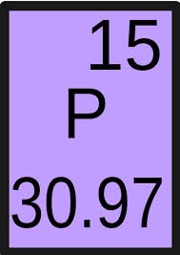
- Atomic Mass - _________
- Name - ________________
- Metal or non-metal - ____________
- Number of electrons - _________
- Number of electron shells - ________
- Number of valence electrons - ________(electrons in the outer shell)
- Number of neutrons - ________
- Bohr diagram of element –

- List as many physical properties
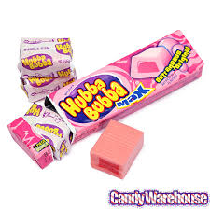
of this item as you can.

